# Task C.1

## Output a – E/R Diagram

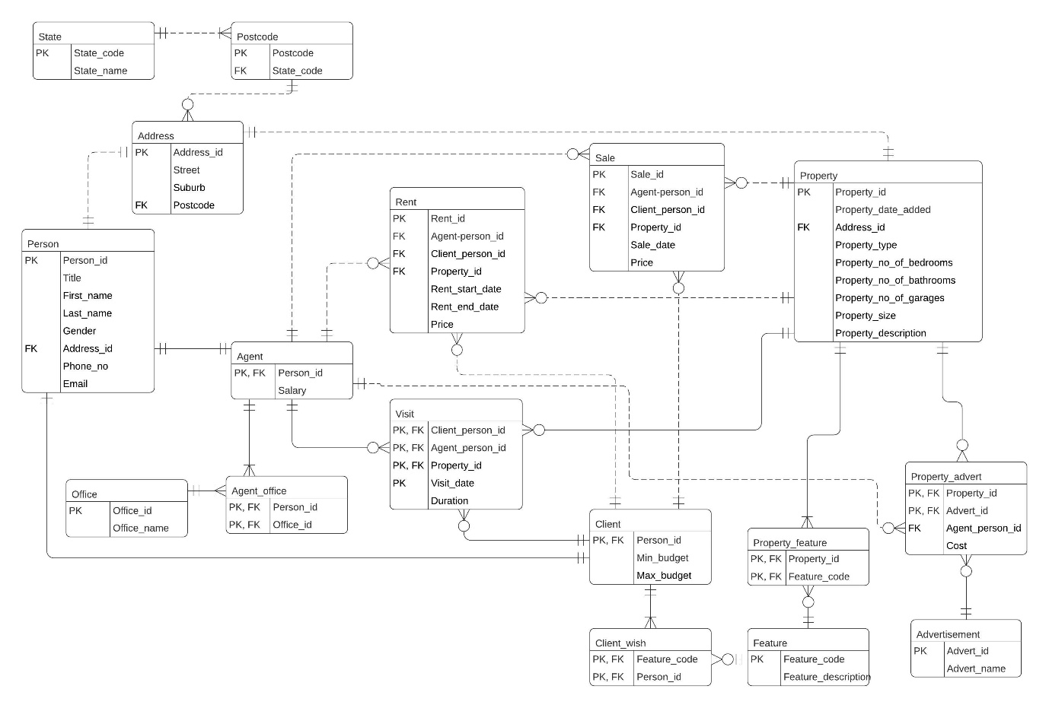

## Output b – Data Cleaning

### b1. Address

SELECT COUNT(*)

FROM mre_address; -- 13,204 rows



Firstly, checked for duplicate address_id

SELECT COUNT(DISTINCT(address_id))

FROM mre_address; -- 13,204 rows

Secondly, checked for distinct street

SELECT COUNT(DISTINCT(street))

FROM mre_address; -- 13,156 rows

However, among the street records, it was found that a number of records contain the same street data but different suburbs, as such it was further evaluated based on distinct street, suburb and postcode combinations.

Using the following formula, there were no addresses that were not used in the Property and Person tables.

SELECT address_id

FROM mre_address

WHERE NOT address_id IN (SELECT address_id FROM

mre_property)

AND NOT address_id IN (SELECT address_id FROM mre_person);

As such, we derived that there are no records that are required to be deleted from the address table.

### b2. Advertisement

SELECT COUNT(*) FROM mre_advertisement; -- 25 rows



Since that there were only 25 rows, visual inspection showed that there were no null records and the following two confirmed that there were no duplicate records:

SELECT COUNT(DISTINCT(advert_id))

FROM mre_advertisement; -- 25 rows

SELECT COUNT(DISTINCT(advert_name))

FROM mre_advertisement; -- 25 rows

We concluded that there needed no cleaning for the advertisement table.

### b3. Agent

SELECT COUNT(*)

FROM MRE_Agent; -- 2,469 rows



When using the following query, we found that only 2,468 people are agents, meaning that one agent is non-existent

SELECT COUNT(*)

FROM (SELECT * FROM MRE_Person p, MRE_Agent a

WHERE p.person_id = a.person_id); -- 2,468 rows

SELECT *

FROM mre_person

WHERE NOT person_id IN (SELECT person_id FROM mre_person);



Using the following syntax, that row was deleted:

DELETE FROM MRE_Agent

WHERE NOT person_id IN (SELECT person_id FROM MRE_person); -- 1 row deleted

Subsequently, another error was found in 2 rows where salary was less than 0

SELECT * FROM mre_agent

WHERE salary < 0; -- 2 rows



DELETE FROM mre_agent

WHERE salary < 0; -- 2 rows deleted

Checking the number of rows again:

SELECT COUNT(*)

FROM MRE_Agent; -- 2,466 rows



### b4. Agent_Office

SELECT COUNT(*)

FROM mre_agent_office; -- 2,529 rows



While the following syntax shows that there are multiple records for the same agent, since an agent can work at multiple office, there is no error

SELECT COUNT(DISTINCT(person_id))

FROM mre_agent_office; -- 2,467 rows

However, checking whether the agent exists, the agent deleted earlier was not found and was subsequently removed.

SELECT *

FROM mre_agent_office

WHERE NOT person_id IN (SELECT person_id FROM mre_agent);



DELETE FROM mre_agent_office

WHERE NOT person_id IN (SELECT person_id FROM mre_agent); -- 1 row deleted

The number of rows in the end is

SELECT COUNT(*)

FROM mre_agent_office; -- 2,528 rows



### b5. Client

SELECT COUNT(*)

FROM mre_client; -- 3,339 rows



However, from the following syntax, there is a client that is not registered as a person

SELECT COUNT(*)

FROM mre_person p, mre_client c

WHERE p.person_id = c.person_id; -- 3,338 rows

SELECY *

FROM mre_client

WHERE NOT person_id IN (SELECT person_id FROM mre_person);



As such, the extra client was deleted with

DELETE FROM mre_client

WHERE NOT person_id IN (SELECT person_id FROM mre_person); -- 1 row deleted

Furthermore, it was found that few records had the max_budget lower than the min_budget, as well as min budget being negative. These rows were then deleted

SELECT *

FROM mre_client

WHERE max_budget < min_budget; -- 3 rows

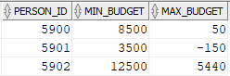

DELETE FROM mre_client

WHERE max_budget < min_budget; -- 3 rows deleted

Checking for any min_budget or max_budget being negative yield no results.

Checking the number of rows again:

SELECT COUNT(*)

FROM mre_client; -- 3,338 rows



### b6. Client_Wish

SELECT COUNT(*)

FROM mre_client_wish; -- 1,204 rows



Since a single client can have many wishes, checking for distinct clients is useless. Checking for repeated person_id and feature code also proved no duplicates. As such, no changes were needed.

### b7. Feature

SELECT COUNT(*)

FROM mre_feature; -- 726 rows



Checking for duplicate feature_id and feature_description showed no duplicates.

### b8. Office

SELECT COUNT(*)

FROM mre_office; -- 1,177 rows



Checking for duplicates of office_id and office_name showed no duplicates.

### b9. Person

SELECT COUNT(*)

FROM mre_person; -- 7,000 rows



Looking for duplicates person_id, 4 deplicates were found for person_id = 6995

SELECT COUNT(DISTINCT(person_id))

FROM MRE_Person; -- 6,997 rows

SELECT person_id

FROM mre_person GROUP BY person_id HAVING COUNT(*) > 1;



Using the following syntax, the duplicate records were deleted:

DELETE FROM MRE_Person p

WHERE rowid > (SELECT MIN(rowid)FROM MRE_Person p2

WHERE p.person_id = p2.person_id); -- 3 rows deleted

Checking through phone_no and email showed no other duplicates, the final number is:

SELECT COUNT(*)

FROM mre_person; - 6,997 rows



### b10. Postcode

SELECT COUNT(*)

FROM mre_postcode; -- 689 rows



No duplicate or nulls were found in the postcode table.

### b11. Property

SELECT COUNT(*)

FROM mre_property; -- 6,226 rows



There were a large number of records that were duplicated

SELECT COUNT(DISTINCT(property_id)) FROM mre_property; -- 6,208 rows

SELECT *

FROM mre_property p

WHERE rowid > (SELECT MIN(rowid)FROM mre_property p2

WHERE p.property_id = p2.property_id);

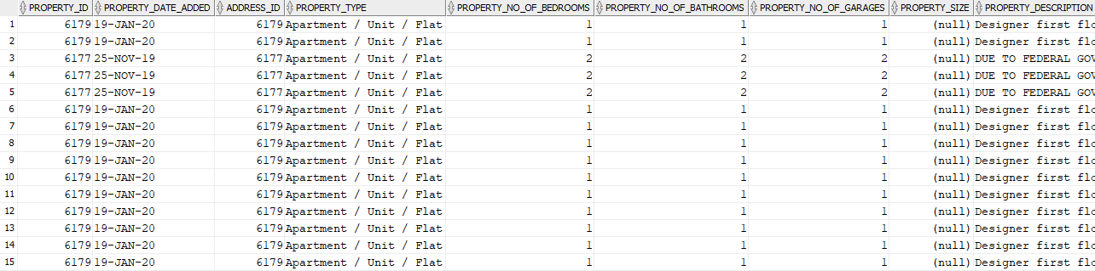

The following syntax was used to delete the duplicate rows

DELETE FROM MRE_Property p

WHERE rowid > (SELECT MIN(rowid)FROM MRE_Property p2

WHERE p.property_id = p2.property_id); -- 18 rows deleted

The new number of rows is:

SELECT COUNT(*)

FROM mre_property; -- 6,208 rows



### b12. Property_Advert

SELECT COUNT(*)

FROM mre_property_advert; -- 3,646 rows



No duplicate records or null records were found in this table

### b13. Property_Feature

SELECT COUNT(*)

FROM mre_property_feature; -- 30,373 rows



No duplicate or null records were found

### b14. Rent

SELECT COUNT(*)

FROM mre_rent; --3,284 rows



Records were checked for duplicate and non were found but one record was found for rent_end_date before rent_start_date

SELECT *

FROM mre_rent

WHERE rent_end_date <= rent_start_date;



The record was then deleted

DELETE FROM MRE_Rent WHERE rent_id IN (SELECT rent_id FROM MRE_Rent WHERE rent_end_date < rent_start_date); -- 1 row deleted

SELECT COUNT(*)

FROM MRE_Rent; -- 3,283 rows



### b15. Sale

SELECT COUNT(*)

FROM mre_sale; -- 2,925 rows



The following syntax was used and found that a number of records had null client_person_id and sale_date. However, as these rows may be kept for record to show agent client relationships for unsold properties, the rows are temporarily kept.

### b16. State

SELECT *

FROM mre_state; -- 9 rows

There were little number of rows so visual inspection was possible and one row was identified as NULL state_code and UNKNOWN state_name which was promptly deleted

DELETE FROM MRE_State

WHERE state_code IS NULL; -- 1 row deleted

New number of records is:

SELECT COUNT(*)

FROM mre_state; -- 8 rows



### b17. Visit

SELECT COUNT(*)

FROM mre_visit; -- 575 rows



A record was found that the agent or client did not exist in mre_agent or mre_client

SELECT *

FROM mre_visit

WHERE NOT agent_person_id IN (SELECT person_ID FROM mre_agent)

OR NOT client_person_id IN (SELECT person_id FROM mre_client); -- 1 row



That record was promptly deleted

DELETE

FROM mre_visit

WHERE NOT agent_person_id IN (SELECT person_ID FROM mre_agent)

OR NOT client_person_id IN (SELECT person_id FROM mre_client); -- 1 row deleted

Updated number of rows is:

SELECT COUNT(*) FROM mre_visit; -- 574 rows



### b18. Special Case

We checked for person records that did not reference any addresses. Using the following code, we found that there was a person record which address_id did not exist and the record contains majority of null fields. This record could not be detected through using ‘IS NULL’ because the fields while displaying null, was actually a string ‘null’.

SELECT *

FROM mre_person

WHERE NOT address_id IN (SELECT address_id FROM mre_address);



As a safety precaution, we checked through Agent, Client, Client_Wish to this person_id.

We found no such persin in the Agent table but there exists a normal record in the Client table.



We continued to check the Client_Wish table and found one record of this person:



Looking into the Feature table, we found that feature_code = 726 is labelled as Fake Feature.



After taking the above-mentioned factors into consideration, we decided to delete person_id = 7001 from the Person, Client and Client_Wish table as well as feature_code = 726 from the feature table.

### b19. Summary

After analysing the operational database, the following errors were identified:

1. Agent table person_id NOT IN Person table person_id – 1 row deleted
2. Agent salary < 0 – 2 rows deleted
3. Agent person_id NOT IN Person table person_id – 1 row deleted
4. Client table person_id NOT IN Person table person_id – 1 row deleted
5. Client max_budget < min_budget – 3 rows deleted
6. Duplicate person record – 3 rows deleted
7. Duplicate property record – 18 rows deleted
8. Rent rent_end_date < rent_start_date – 1 row deleted
9. State state_code IS NULL – 1 row deleted
10. Visit table agent_person_id or client_person_id NOT IN Person table person_id – 1 row deleted
11. Special Case: Person address_id non-existent – 1 row deleted

Client record referencing above – 1 row deleted

Client_wish record referencing above – 1 row deleted

Feature record ‘Fake Feature’ – 1 row deleted

## Output c – Star Schemas

### c1 Level 2

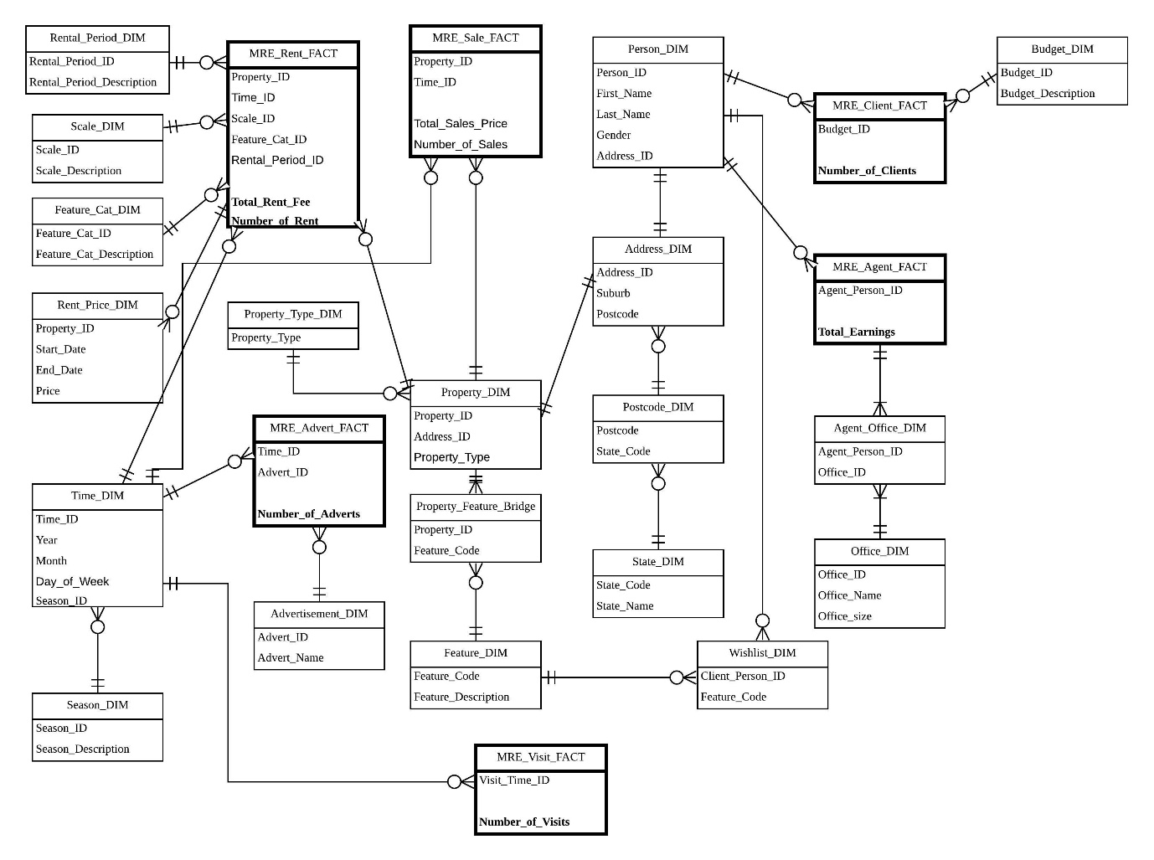

### c2 Level 0

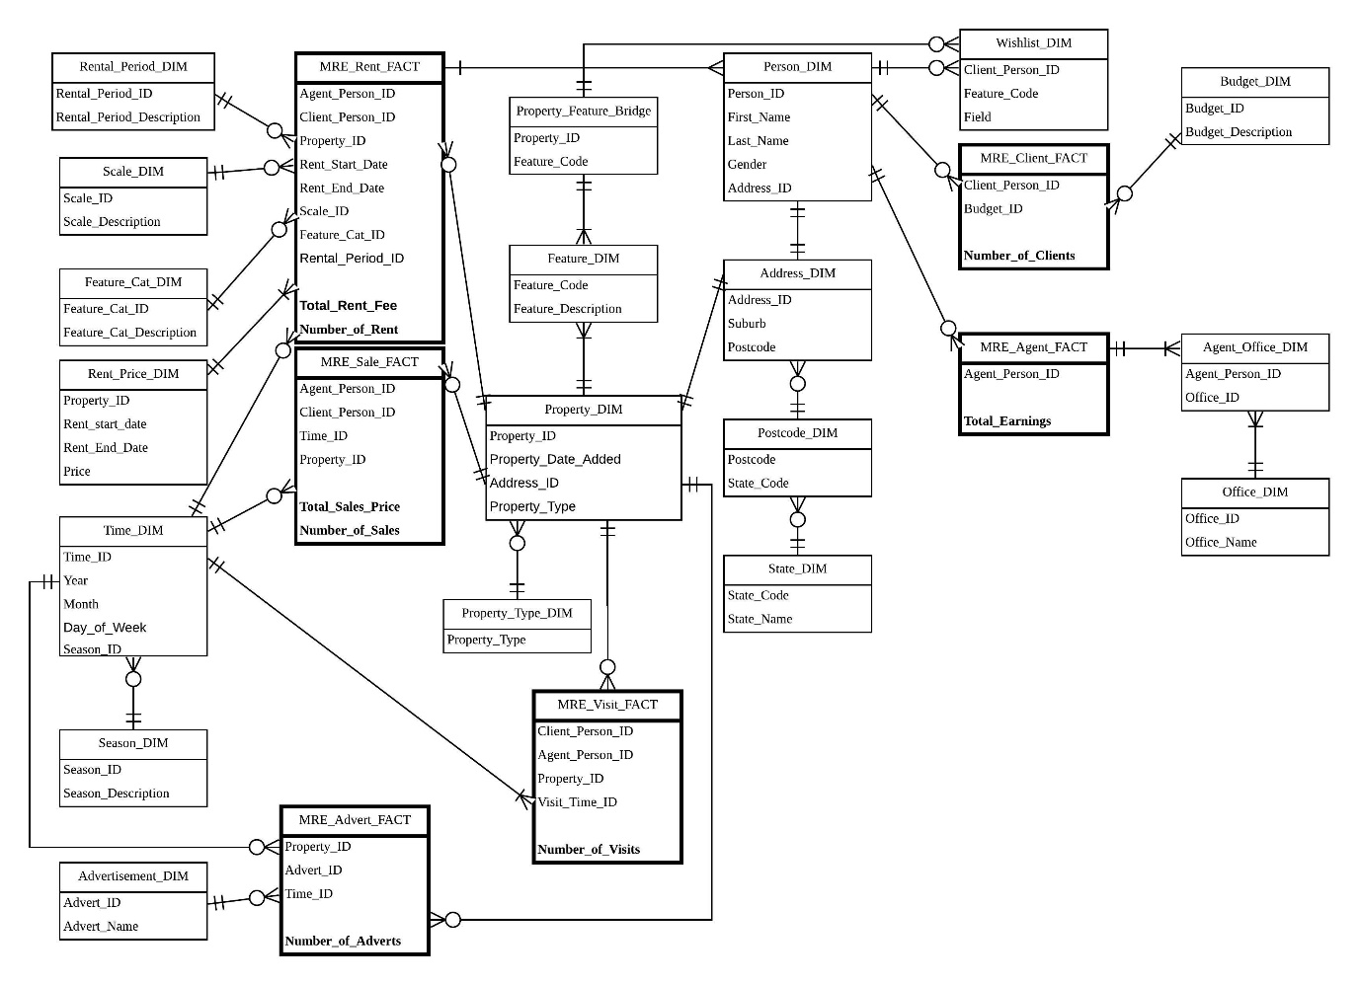

## Output d – Hierarchy or non-Hierarchy Explanation

We used hierarchy for address as it allows easy drill down into data for viewing different granularity. It is preferred compared to non-hierarchy as it allows optional usage of the lower level dimensions when needed but at the same time reduce the storage capacity in higher level tables as state names is longer than using a number to represent them.

## Output e - Temporal Dimension SCD Type Explanation

SCD Type 4 was chosen as rental price may not necessarily be fixed for each rental agreement of the same property over time. Therefore, MRE_Rent_FACT does not need to keep the price information, but the property_id, rent_start_date and rent_end­_date. The rent prices are kept separately in the Rent_Price_DIM, where the price can be seen for each rental agreement made with clients (after joining with property_id, rent_start_date, rent_end_date).

SCD Type 0 only stores the initial value of the rent price, which is not suitable for the fact measure. SCD Type 1 stores the latest rent price, but not the values before and therefore, it is not possible to view the change in rental prices over time.

SCD Type 2 was initially considered, but it had several redundancies such as adding sequence number to the property_id for each transaction, and the current flag to show whether it is the latest record. While SCD Type 3 has a unique property_id with no number sequencing, it uses current price and previous price to store the values. This is not suitable for storing rental prices as the property may not be always out on rent, as there might be vacancies for some periods of time.

SCD Type 0 is suitable for storing property sale prices as once a property sale has been made, the original price value is recorded. There will be no further changes to the property price.

## Output f – Differences between the Two Versions of Star/Snowflake Schema

Level 2 star/snowflake schema is the highest aggregation and level 0 star/snowflake schema has no aggregation. In level 2 MRE_Sale_Fact has 2 dimensions of Property_DIM and Time_DIM. In level 0, MRE_Sale_Fact dimension was further broken down to Property_DIM, Time_DIM, PropertyType_DIM and Person_DIM.

Level 2 – MRE_Sale_Fact

Looking at the data retrieved from Level 2 sale fact table, the management will only able to analyse the sales price and the number of times the property had been resold. However if the management were to drill down for further information regarding how well their agents are performing in term of sale, or some client insight this level 2 sale fact will no provide such data.

Level 0 – MRE_Sale_Fact

From Level 0 sale fact table, the management would able to know how well their agent performed. In this snapshot of data retrieved from level 0 sale fact table, agent ID 2 is performing well in selling the property. Therefore, this shows that the level of aggregation is low in level 0 MRE_Sale_Fact, where the fact was broken down to more detail.

For rent fact table, Level 2 has a higher aggregation compare to level 0. This means that the management will more likely to get more information from level 0 rent fact table.

Level 2 – MRE_Rent_Fact

Looking at the data retrieved from Level 2 rent fact table, which consist of property id, time id, scale id, feature category id, total rent fee and number of rent. This fact table only provided limited information for the management. This table was aggregated with agent, client, rent start date, rent end date rental and rental period. For instance, looking at property id ‘ 2945’ there is only 1 time id ‘202001TUE’ in Level 2 star schema.

Level 0 – MRE_Rent_Fact



In Level 0 star schema rent fact, the time id was broken down into rent start date and rent end date. Agent and client was added into the table as well. The table records more details compare to level 2 star schema.

In term of client factor, Level 2 star schema client fact table only contain 3 rows of data with budget ID and total number of client. Looking at the data, budget ID of 1 which is low budget, consist of 1581 clients.

level 2 – MRE_Client _Fact

However, in Level 0 star schema client fact table, budget ID 1 can be brake down into 1581 rows of data, which consists of a client ID. Level 0 star schema shows the budget category for each of every client.

Level 0 – MRE_Client fact

In term of visit fact, Level 2 visit fact table contain visit time id and number of visits. To the management, this table only provide the number of visits in each visit time period. This table was constructed by aggregating the client, agent and property.

Level 2 – MRE_Visit_Fact

In Level 0, the fact table brake down the aggregation back to client, agent and property. In level 2 visit fact table, visit time id ‘202003THU’ has 58 number of visits. However, in level 0 visit fact table, time ID of ‘202003THU’ was broken down based on client, agent and property. Therefore, for each different client, will have same agent id and property. The total of number visits will add up to 58 for the time ID ‘202003THU’ in Level 0 visit fact table.

Level 0 – MRE_Visit Fact

For the advertisement fact, level 2 star schema shows that the time ID ‘202004WED’, advertisement ID ‘25’ has 4 advertisements. This fact table only show the number of advertisement as general, but the total number was aggregated with different property.

Level 2 – MRE_advert_fact

In Level 0, for time ID ‘202004WED’ the data was broken down into 4 different rows with different property ID. This indicates that for the time id ‘202004WED’ the advertisement was published for 4 different property at the same time. Therefore, Level 0 advertisement fact table has no aggregation compared to level 2 advertisement fact of high aggregation.

Level 0 – MRE_advert_fact

# Task 2

## Output a – SQL Statement for Level 2 Star Schema

-- Task c 2b)

-- Level 2 multi-fact star schema

DROP TABLE MRE_scale_DIM_l2 PURGE;

DROP TABLE MRE_feature_cat_DIM_l2 PURGE;

DROP TABLE MRE_property_dim_l2 PURGE;

DROP TABLE MRE_property_feature_bridge_l2 PURGE;

DROP TABLE MRE_feature_dim_l2 PURGE;

DROP TABLE MRE_property_type_dim_l2 PURGE;

DROP TABLE MRE_address_dim_l2 PURGE;

DROP TABLE MRE_postcode_dim_l2 PURGE;

DROP TABLE MRE_state_dim_l2 PURGE;

DROP TABLE MRE_advertisement_dim_l2 PURGE;

DROP TABLE MRE_person_dim_l2 PURGE;

DROP TABLE MRE_agent_office_dim_l2 PURGE;

DROP TABLE MRE_office_dim_l2 PURGE;

DROP TABLE MRE_budget_dim_l2 PURGE;

DROP TABLE MRE_rental_period_dim_l2 PURGE;

DROP TABLE MRE_wishlist_dim_l2 PURGE;

DROP TABLE MRE_rent_price_dim_l2 PURGE;

DROP TABLE MRE_temp_time_dim_l2 PURGE;

DROP TABLE MRE_time_dim_l2 PURGE;

DROP TABLE MRE_season_dim_l2 PURGE;

DROP TABLE MRE_agent_fact_l2 PURGE;

DROP TABLE MRE_temp_client_l2 PURGE;

DROP TABLE MRE_client_fact_l2 PURGE;

DROP TABLE MRE_temp_rent_fact_l2 PURGE;

DROP TABLE MRE_rent_fact_l2 PURGE;

DROP TABLE MRE_temp_visit_l2 PURGE;

DROP TABLE MRE_visit_fact_l2 PURGE;

DROP TABLE MRE_temp_sale_fact_l2 PURGE;

DROP TABLE MRE_sale_fact_l2 PURGE;

DROP TABLE MRE_temp_advert_l2 PURGE;

DROP TABLE MRE_advert_fact_l2 PURGE;

-- Dimension tables

-- Scale dimension

create table mre_scale_dim_l2 (

scale_id numeric(1),

scale_description char(20));

insert into mre_scale_dim_l2 values(1, 'extra small');

insert into mre_scale_dim_l2 values(2, 'small');

insert into mre_scale_dim_l2 values(3, 'medium');

insert into mre_scale_dim_l2 values(4, 'large');

insert into mre_scale_dim_l2 values(5, 'extra large');

-- Feature catagory dimension

create table mre_feature_cat_dim_l2(

feature_cat_id numeric(1),

feature_cat_description char(15));

insert into mre_feature_cat_dim_l2 values(1,'basic');

insert into mre_feature_cat_dim_l2 values(2,'standard');

insert into mre_feature_cat_dim_l2 values(3,'luxurious');

-- Property dimension

create table mre_property_dim_l2

as select property_id, address_id, property_type

from mre_property;

-- Property feature bridge

create table mre_property_feature_bridge_l2

as select distinct *

from mre_property_feature;

-- feature dim

create table mre_feature_dim_l2

as select distinct *

from mre_feature;

-- property type dimension

create table mre_property_type_dim_l2

as select distinct(property_type)

from mre_property;

-- Address dim

create table mre_address_dim_l2

as select distinct address_id, suburb, postcode

from mre_address;

-- postcode dim

create table mre_postcode_dim_l2

as select distinct *

from mre_postcode;

-- state dim

create table mre_state_dim_l2

as select *

from mre_state;

-- Advertisment dim

create table mre_advertisement_dim_l2

as select distinct *

from mre_advertisement;

-- person dim

create table mre_person_dim_l2

as select person_id, first_name, last_name, gender, address_id

from mre_person;

-- agent office dim

create table mre_agent_office_dim_l2

as select distinct person_id as agent_person_id, office_id

from mre_agent_office;

-- office dim

create table mre_office_dim_l2

as select *

from mre_office;

alter table mre_office_dim_l2

add office_size char(10);

update mre_office_dim_l2 t

set office_size =

(select case

when count(person_id) < 4 then 'small'

when count(person_id) between 4 and 12 then 'medium'

else 'big'

end

from mre_agent_office ao

where t.office_id = ao.office_id);

-- Budget dimension

create table mre_budget_dim_l2(

budget_id char(2),

budget_description varchar(100));

insert into mre_budget_dim_l2 values ('l', 'Budget between 0 and 1000');

insert into mre_budget_dim_l2 values ('m', 'Budget between 1001 and 100000');

insert into mre_budget_dim_l2 values ('h', 'Budget more than 100001');

-- Rental period DIM

create table mre_rental_period_dim_l2(

rental_period_id numeric(2),

rental_period_description varchar(50));

insert into mre_rental_period_dim_l2 values (1, 'short');

insert into mre_rental_period_dim_l2 values (2, 'medium');

insert into mre_rental_period_dim_l2 values (3, 'long');

-- whishlist dim

create table mre_wishlist_dim_l2

as select distinct *

from mre_client_wish;

-- Rent price dimension

create table mre_rent_price_dim_l2

as select property_id, rent_start_date, rent_end_date, price

from mre_rent;

-- Time dimension

create table mre_temp_time_dim_l2

as select *

from (select distinct sale_date as dates from mre_sale

where sale_date is not null

union

select distinct rent_start_date from mre_rent

where rent_start_date is not null

union

select distinct rent_end_date from mre_rent

where rent_end_date is not null

);

alter table mre_temp_time_dim_l2

add (

time_id varchar(20),

Year numeric(4),

Month numeric(2),

Season_id numeric(1));

update mre_temp_time_dim_l2

set time_id = to_char(dates, 'YYYYMMDY'),

year = to_char(dates, 'YYYY'),

month = to_char(dates, 'MM');

update mre_temp_time_dim_l2

set season_id =

case

when month between 3 and 5 then 1

when month between 6 and 8 then 2

when month between 9 and 11 then 3

else 4

end;

create table mre_time_dim_l2

as select DISTINCT(time_id), year, month, season_id

from mre_temp_time_dim_l2;

-- Season DIM

create table mre_season_dim_l2(

season_id numeric(1),

season_description char(10));

insert into mre_season_dim_l2 values(1, 'Spring');

insert into mre_season_dim_l2 values(2, 'Summer');

insert into mre_season_dim_l2 values(3, 'Autumn');

insert into mre_season_dim_l2 values(4, 'Winter');

-- Fact tables

-- Agent fact table

create table mre_agent_fact_l2

as select a.person_id as agent_person_id, sum(nvl(s.price, 0)) + nvl(sum(nvl(r.price, 0)/7*(r.rent_end_date - r.rent_start_date)), 0) as total_earnings

from mre_agent a, mre_sale s, mre_rent r

where a.person_id = s.agent_person_id (+)

and a.person_id = r.agent_person_id (+)

group by a.person_id;

-- client fact table

create table mre_temp_client_l2

as select max_budget from mre_client;

alter table mre_temp_client_l2

add budget_id char(2);

update mre_temp_client_l2

set budget_id = case

when max_budget between 0 and 1000 then 'l'

when max_budget between 1001 and 100000 then 'm'

else 'h' end;

create table mre_client_fact_l2

as select budget_id , count(*) as total_number_of_client

from mre_temp_client_l2

group by budget_id;

-- rent fact

create table mre_temp_rent_fact_l2

as select distinct

r.property_id ,

r.rent_start_date as dates,

p.property_no_of_bedrooms,

COUNT(*) as number_of_features,

r.price,

r.rent_end_date,

r.rent_start_date,

count(distinct(rent_id)) as num_of_rent

from mre_rent r, mre_property p, mre_property_feature f

where r.property_id = p.property_id

and p.property_id = f.property_id

and r.rent_start_date is not null

GROUP BY r.property_id, p.property_no_of_bedrooms, r.price, r.rent_end_date, r.rent_start_date;

alter table mre_temp_rent_fact_l2 add (

time_id varchar(20),

scale_id numeric(1),

feature_cat_id numeric(1));

update mre_temp_rent_fact_l2

set time_id = to_char(rent_start_date, 'YYYYMMDY'),

scale_id =

case

when property_no_of_bedrooms between 0 and 1 then 1

when property_no_of_bedrooms between 2 and 3 then 2

when property_no_of_bedrooms between 4 and 6 then 3

when property_no_of_bedrooms between 7 and 10 then 4

else 5

end;

update mre_temp_rent_fact_l2 t

set feature_cat_id =

(case when number_of_features < 10 then 1

when number_of_features between 10 and 20 then 2

else 3

end);

create table mre_rent_fact_l2

as select property_id, time_id, scale_id, feature_cat_id, (price / 7 *(rent_end_date - rent_start_date)) as total_rent_fee, num_of_rent as number_of_rent

from mre_temp_rent_fact_l2;

-- visit fact

create table mre_temp_visit_l2

as select visit_date

from mre_visit;

alter table mre_temp_visit_l2

add visit_time_id varchar(20);

update mre_temp_visit_l2

set visit_time_id = to_char(visit_date, 'YYYYMMDY');

create table mre_visit_fact_l2

as select visit_time_id, count(*) as number_of_visit

from mre_temp_visit_l2

group by visit_time_id;

-- sale fact

create table mre_temp_sale_fact_l2

as select s.property_id, s.sale_date, p.property_type, s.price

from mre_sale s, mre_property p

where s.property_id = p.property_id

and sale_date is not null;

alter table mre_temp_sale_fact_l2 add (

time_id varchar(20));

set define off;

update mre_temp_sale_fact_l2

set time_id = to_char(sale_date, 'YYYYMMDY');

create table mre_sale_fact_l2

as select property_id, time_id, sum(price) as total_sales_price, count(*) as number_of_sales

from mre_temp_sale_fact_l2

group by property_id, time_id;

-- Advert fact

create table mre_temp_advert_l2

as select distinct a.advert_id, p.property_date_added

from mre_property_advert a, mre_property p

where p.property_id = a.property_id;

alter table mre_temp_advert_l2

add time_id varchar(20);

update mre_temp_advert_l2

set time_id = to_char(property_date_added, 'YYYYMMDY');

create table mre_advert_fact_l2

as select time_id, advert_id, count(*) as number_of_adverts

from mre_temp_advert_l2

group by time_id, advert_id;

commit;

## Output b – SQL Statement for Level 0 Star Schema

-- Task C 2b)

-- Level 0 multi-fact star schema

DROP TABLE MRE_Scale_DIM_l0 PURGE;

DROP TABLE MRE_Feature_Cat_DIM_l0 PURGE;

DROP TABLE MRE_Property_DIM_l0 PURGE;

DROP TABLE MRE_Property_Feature_Bridge_l0 PURGE;

DROP TABLE MRE_Feature_DIM_l0 PURGE;

DROP TABLE MRE_Wishlist_DIM_L0 PURGE;

DROP TABLE MRE_Property_Type_DIM_l0 PURGE;

DROP TABLE MRE_Address_DIM_l0 PURGE;

DROP TABLE MRE_Postcode_DIM_l0 PURGE;

DROP TABLE MRE_State_DIM_l0 PURGE;

DROP TABLE MRE_Advertisement_DIM_l0 PURGE;

DROP TABLE MRE_Person_DIM_l0 PURGE;

DROP TABLE MRE_Agent_Office_DIM_l0 PURGE;

DROP TABLE MRE_Office_DIM_l0 PURGE;

DROP TABLE MRE_Office_Size_DIM_L0 PURGE;

DROP TABLE MRE_Office_TempDIM_L0 PURGE;

DROP TABLE MRE_Budget_DIM_l0 PURGE;

DROP TABLE MRE_Rental_Period_DIM_l0 PURGE;

DROP TABLE MRE_Rent_Price_DIM_l0 PURGE;

DROP TABLE MRE_Season_DIM_l0 PURGE;

DROP TABLE MRE_Time_DIM_l0 PURGE;

DROP TABLE MRE_Sale_FACT_l0 PURGE;

DROP TABLE MRE_Rent_TempFACT_L0 PURGE;

DROP TABLE MRE_Rent_FACT_l0 PURGE;

DROP TABLE MRE_Client_TempFACT_L0 PURGE;

DROP TABLE MRE_Client_FACT_l0 PURGE;

DROP TABLE MRE_Agent_FACT_l0 PURGE;

DROP TABLE MRE_Visit_FACT_l0 PURGE;

DROP TABLE MRE_Advert_FACT_l0 PURGE;

--------------------------------

-- Implement dimension tables --

--------------------------------

-- MRE_Scale_DIM_L0

CREATE TABLE MRE_Scale_DIM_L0 (

Scale_ID NUMBER,

Scale_Description VARCHAR2(100)

);

INSERT INTO MRE_Scale_DIM_L0 VALUES (1, 'Extra small: <= 1 bedroom');

INSERT INTO MRE_Scale_DIM_L0 VALUES (2, 'Small: 2-3 bedrooms');

INSERT INTO MRE_Scale_DIM_L0 VALUES (3, 'Medium: 3-6 bedrooms');

INSERT INTO MRE_Scale_DIM_L0 VALUES (4, 'Large: 6-10 bedrooms');

INSERT INTO MRE_Scale_DIM_L0 VALUES (5, 'Extra large: > 10 bedrooms');

-- MRE_Feature_CAT_DIM_L0

CREATE TABLE MRE_Feature_CAT_DIM_L0 (

Feature_CAT_ID NUMBER,

Feature_CAT_Description VARCHAR2(100)

);

INSERT INTO MRE_Feature_CAT_DIM_L0 VALUES (1, 'Very basic: < 10 features');

INSERT INTO MRE_Feature_CAT_DIM_L0 VALUES (2, 'Standard: 10-20 features');

INSERT INTO MRE_Feature_CAT_DIM_L0 VALUES (3, 'Luxurious: > 20 features');

-- MRE_Property_DIM_L0

CREATE TABLE MRE_Property_DIM_L0 AS (

SELECT

p.Property_ID,

p.Property_Date_Added,

p.address_id,

p.property_type

FROM MRE_Property p

);

-- Property_Feature_Bridge_L0

CREATE TABLE MRE_Property_Feature_Bridge_L0 AS (

SELECT DISTINCT * FROM MRE_Property_Feature

);

-- MRE_Feature_DIM_L0

CREATE TABLE MRE_Feature_DIM_L0 AS (

SELECT DISTINCT * FROM MRE_Feature

);

-- MRE_Wishlist_DIM_L0

CREATE TABLE MRE_Wishlist_DIM_L0 AS (

SELECT

Person_ID AS Client_Person_ID,

Feature_Code

FROM MRE_Client_Wish

);

-- MRE_Property_Type_DIM_L0

CREATE TABLE MRE_Property_Type_DIM_L0 AS (

SELECT DISTINCT(property_type)

FROM mre_property

);

-- MRE_Address_DIM_L0

CREATE TABLE MRE_Address_DIM_L0 AS (

SELECT DISTINCT

Address_ID,

Street,

Suburb,

Postcode

FROM MRE_Address

);

-- MRE_Postcode_DIM_L0

CREATE TABLE MRE_Postcode_DIM_L0 AS (

SELECT DISTINCT * FROM MRE_Postcode

);

-- MRE_State_DIM_L0

CREATE TABLE MRE_State_DIM_L0 AS (

SELECT DISTINCT * FROM MRE_State

);

-- MRE_Advertisement_DIM_L0

CREATE TABLE MRE_Advertisement_DIM_L0 AS (

SELECT DISTINCT * FROM MRE_Advertisement

);

-- MRE_Person_DIM_L0

CREATE TABLE MRE_Person_DIM_L0 AS (

SELECT DISTINCT

Person_ID,

First_Name,

Last_Name,

Gender,

Address_ID

FROM MRE_Person

);

-- MRE_Agent_Office_DIM_L0

CREATE TABLE MRE_Agent_Office_DIM_L0 AS (

SELECT DISTINCT

Person_ID AS Agent_Person_ID,

Office_ID

FROM MRE_Agent_Office

);

-- MRE_Office_Size_DIM_L0

CREATE TABLE MRE_Office_Size_DIM_L0 (

Office_Size_ID NUMBER,

Office_Size_Description VARCHAR2(60)

);

INSERT INTO MRE_Office_Size_DIM_L0 VALUES (1, 'Small: < 4 employees');

INSERT INTO MRE_Office_Size_DIM_L0 VALUES (2, 'Medium: 4 - 12 employees');

INSERT INTO MRE_Office_Size_DIM_L0 VALUES (3, 'Big: > 12 employees');

-- MRE_Office_TempDIM_L0

CREATE TABLE MRE_Office_TempDIM_L0 AS (

SELECT DISTINCT

ao.Office_ID,

o.Office_Name,

COUNT(ao.Person_ID) AS Num_of_Employees

FROM MRE_Office o, MRE_Agent_Office ao

WHERE o.Office_ID = ao.Office_ID

GROUP BY ao.Office_ID, o.Office_Name

);

ALTER TABLE MRE_Office_TempDIM_L0

ADD Office_Size_ID NUMBER;

UPDATE MRE_Office_TempDIM_L0

SET Office_Size_ID =

(CASE

WHEN Num_of_Employees < 4 THEN 1

WHEN Num_of_Employees BETWEEN 4 AND 12 THEN 2

WHEN Num_of_Employees > 12 THEN 3

END);

CREATE TABLE MRE_Office_DIM_L0 AS (

SELECT

Office_ID,

Office_Name,

Office_Size_ID

FROM MRE_Office_TempDIM_L0

);

-- MRE_Budget_DIM_L0

CREATE TABLE MRE_Budget_DIM_L0 (

Budget_ID NUMBER,

Budget_Description VARCHAR2(100),

Min_Budget NUMBER,

Max_Budget NUMBER

);

INSERT INTO MRE_Budget_DIM_L0 VALUES (1, 'Low [0 to 1,000]', 0, 1000);

INSERT INTO MRE_Budget_DIM_L0 VALUES (3, 'Medium [1,001 to 100,000]', 1001, 100000);

INSERT INTO MRE_Budget_DIM_L0 VALUES (5, 'High [100,001 to 10,000,000]', 100001, 10000000);

-- MRE_Rental_Period_DIM_L0

CREATE TABLE MRE_Rental_Period_DIM_L0 (

Rental_Period_ID NUMBER,

Rental_Period_Description VARCHAR2(60)

);

INSERT INTO MRE_Rental_Period_DIM_L0 VALUES (1, 'Short: < 6 months');

INSERT INTO MRE_Rental_Period_DIM_L0 VALUES (2, 'Medium: 6 - 12 months');

INSERT INTO MRE_Rental_Period_DIM_L0 VALUES (3, 'Long: > 12 months');

-- MRE_Rent_Price_DIM_L0

CREATE TABLE MRE_Rent_Price_DIM_L0 AS (

SELECT DISTINCT

Property_ID,

Rent_Start_Date AS Start_date,

Rent_End_Date AS End_date,

Price

FROM MRE_Rent

);

-- MRE_Season_DIM_L0

CREATE TABLE MRE_Season_DIM_L0 (

Season_ID NUMBER,

Season_Description VARCHAR2(10)

);

INSERT INTO MRE_Season_DIM_L0 VALUES (1, 'Summer');

INSERT INTO MRE_Season_DIM_L0 VALUES (2, 'Autumn');

INSERT INTO MRE_Season_DIM_L0 VALUES (3, 'Winter');

INSERT INTO MRE_Season_DIM_L0 VALUES (4, 'Spring');

-- MRE_Time_DIM_L0

CREATE TABLE MRE_Time_DIM_L0 AS (

SELECT DISTINCT

TO_CHAR(d.dates, 'YYYYMMDY') AS Time_ID,

TO_CHAR(d.dates, 'YYYY') AS Year,

TO_NUMBER(TO_CHAR(d.dates, 'MM'), '99') AS Month,

TO_CHAR(d.dates, 'DY') AS Day_of_Week

FROM (

SELECT DISTINCT Sale_Date AS DATES FROM MRE_Sale

WHERE Sale_Date IS NOT NULL

UNION

SELECT DISTINCT Rent_Start_Date FROM MRE_Rent

WHERE Rent_Start_Date IS NOT NULL

UNION

SELECT DISTINCT Rent_End_Date FROM MRE_Rent

WHERE Rent_End_Date IS NOT NULL

) d

);

ALTER TABLE MRE_Time_DIM_L0

ADD Season_ID NUMBER;

UPDATE MRE_Time_DIM_L0

SET Season_ID =

(CASE

WHEN Month = 12 OR Month BETWEEN 1 AND 2 THEN 1

WHEN Month BETWEEN 3 AND 5 THEN 2

WHEN Month BETWEEN 6 AND 8 THEN 3

WHEN Month BETWEEN 9 AND 11 THEN 4

END);

---------------------------

-- Implement fact tables --

---------------------------

-- MRE_Sale_FACT_L0

CREATE TABLE MRE_Sale_FACT_L0 AS (

SELECT

s.Agent_Person_ID,

s.Client_Person_ID,

TO_CHAR(s.Sale_Date, 'YYYYMMDY') AS Time_ID,

s.Property_ID,

s.Price AS Total_Sales_Price,

COUNT(s.Sale_ID) AS Number_of_Sales

FROM MRE_Sale s, MRE_Property p

WHERE s.Property_ID = p.Property_ID

AND s.Client_Person_ID IS NOT NULL

AND s.Sale_Date IS NOT NULL

GROUP BY s.Agent_Person_ID, s.Client_Person_ID, TO_CHAR(s.Sale_Date, 'YYYYMMDY'), s.Property_ID, s.Price

);

-- MRE_Rent_FACT_L0

CREATE TABLE MRE_Rent_TempFACT_L0 AS (

SELECT

r.Agent_Person_ID,

r.Client_Person_ID,

r.Property_ID,

r.Rent_Start_Date,

r.Rent_End_Date,

p.Property_No_of_Bedrooms AS Number_of_bedrooms,

COUNT(pf.Feature_Code) AS Number_of_features,

ROUND((r.Price / 7) * (Rent_End_Date - Rent_Start_Date), 2) AS Total_Rent_Fee,

COUNT(DISTINCT r.Rent_ID) AS Number_of_Rent

FROM MRE_Rent r, MRE_Property p, MRE_Property_Feature pf

WHERE r.Property_ID = p.Property_ID

AND pf.Property_ID = p.Property_ID

AND r.Client_Person_ID IS NOT NULL

AND r.Rent_Start_Date IS NOT NULL

AND r.Rent_End_Date IS NOT NULL

GROUP BY r.Agent_Person_ID, r.Client_Person_ID, r.Property_ID, r.Rent_Start_Date, r.Rent_End_Date,

p.Property_No_of_Bedrooms, ROUND((r.Price / 7) * (Rent_End_Date - Rent_Start_Date), 2)

);

ALTER TABLE MRE_Rent_TempFACT_L0

ADD (Rental_Period_ID NUMBER,

Scale_ID NUMBER,

Feature_Cat_ID NUMBER);

UPDATE MRE_Rent_TempFACT_L0

SET Rental_Period_ID =

(CASE

WHEN MONTHS_BETWEEN(Rent_Start_Date, Rent_End_Date) < 6 THEN 1

WHEN MONTHS_BETWEEN(Rent_Start_Date, Rent_End_Date) BETWEEN 6 AND 12 THEN 2

WHEN MONTHS_BETWEEN(Rent_Start_Date, Rent_End_Date) > 12 THEN 3

END),

Scale_ID =

(CASE

WHEN Number_of_bedrooms <= 1 THEN 1

WHEN Number_of_bedrooms BETWEEN 2 AND 3 THEN 2

WHEN Number_of_bedrooms BETWEEN 4 AND 6 THEN 3

WHEN Number_of_bedrooms BETWEEN 7 AND 10 THEN 4

WHEN Number_of_bedrooms > 10 THEN 5

END),

Feature_Cat_ID =

(CASE

WHEN Number_of_features < 10 THEN 1

WHEN Number_of_features BETWEEN 10 AND 20 THEN 2

WHEN Number_of_features > 20 THEN 3

END)

;

CREATE TABLE MRE_Rent_FACT_L0 AS (

SELECT

Agent_Person_ID,

Client_Person_ID,

Property_ID,

to_char(Rent_Start_Date, 'YYYYMMDY') as rent_start_date,

to_char(Rent_End_Date, 'YYYYMMDY') as rent_end_date,

Rental_Period_ID,

Scale_ID,

Feature_Cat_ID,

Total_Rent_Fee,

Number_of_Rent

FROM MRE_Rent_TempFACT_L0

);

-- MRE_Client_FACT_L0

CREATE TABLE MRE_Client_TempFACT_L0 AS (

SELECT

Person_ID AS Client_Person_ID,

Max_Budget,

COUNT(Person_ID) AS Number_of_Clients

FROM MRE_Client

GROUP BY Person_ID, Min_Budget, Max_Budget

);

ALTER TABLE MRE_Client_TempFACT_L0

ADD Budget_ID VARCHAR2(2);

UPDATE MRE_Client_TempFACT_L0

SET Budget_ID =

(CASE

WHEN Max_Budget >= 0 AND Max_Budget <= 1000 THEN 1

WHEN Max_Budget >= 1001 AND Max_Budget <= 100000 THEN 3

WHEN Max_Budget >= 100001 AND Max_Budget <= 10000000 THEN 5

END);

CREATE TABLE MRE_Client_FACT_L0 AS (

SELECT

Client_Person_ID,

Budget_ID,

Number_of_Clients

FROM MRE_Client_TempFACT_L0

);

-- MRE_Agent_FACT_L0

CREATE TABLE MRE_Agent_FACT_L0 AS (

SELECT * FROM

(SELECT a.person_id as agent_person_id, SUM(nvl(s.price, 0)) + nvl(SUM(nvl(r.price, 0)/7*(r.rent_end_date - r.rent_start_date)), 0) as total_earnings

FROM mre_agent a, mre_sale s, mre_rent r

WHERE a.person_id = s.agent_person_id (+)

AND a.person_id = r.agent_person_id (+)

GROUP BY a.person_id)

);

-- MRE_Visit_FACT_L0

CREATE TABLE MRE_Visit_FACT_L0 AS (

SELECT DISTINCT

Client_Person_ID,

Agent_Person_ID,

Property_ID,

TO_CHAR(Visit_Date, 'YYYYMMDY') AS Time_ID,

COUNT(*) AS Number_of_Visits

FROM MRE_Visit

GROUP BY Client_Person_ID, Agent_Person_ID, Property_ID, TO_CHAR(Visit_Date, 'YYYYMMDY')

);

-- MRE_Advert_FACT_L0

CREATE TABLE MRE_Advert_FACT_L0 AS (

SELECT DISTINCT

pa.Property_ID,

pa.Advert_ID,

TO_CHAR(p.Property_Date_Added, 'YYYYMMDY') AS Time_ID,

COUNT(pa.Advert_ID) AS Number_of_Adverts

FROM MRE_Property_Advert pa, MRE_Property p

WHERE pa.Property_ID = p.Property_ID

GROUP BY pa.Property_ID, pa.Advert_ID, TO_CHAR(p.Property_Date_Added, 'YYYYMMDY')

);

----------------------------------------------------

-- Two-column methodology checking of fact tables --

----------------------------------------------------

-- Numbers should be wrong since tested on non-cleaned data.

-- MRE_Sale_FACT_L0

SELECT SUM(Total_Sales_Price), SUM(Number_of_Sales) FROM MRE_Sale_FACT_L0; -- 702,593,752 and 916

SELECT Agent_Person_ID, SUM(Total_Sales_Price), SUM(Number_Of_Sales) FROM MRE_Sale_FACT_L0 GROUP BY Agent_Person_ID ORDER BY Agent_Person_ID; -- 702,593,752 and 916

SELECT Client_Person_ID, SUM(Total_Sales_Price), SUM(Number_Of_Sales) FROM MRE_Sale_FACT_L0 GROUP BY Client_Person_ID ORDER BY Client_Person_ID; -- 702,593,752 and 916

SELECT Time_ID, SUM(Total_Sales_Price), SUM(Number_Of_Sales) FROM MRE_Sale_FACT_L0 GROUP BY Time_ID ORDER BY Time_ID; -- 702,593,752 and 916

SELECT Property_ID, SUM(Total_Sales_Price), SUM(Number_Of_Sales) FROM MRE_Sale_FACT_L0 GROUP BY Property_ID ORDER BY Property_ID; -- 702,593,752 and 916

SELECT Property_Type, SUM(Total_Sales_Price), SUM(Number_Of_Sales) FROM MRE_Sale_FACT_L0 sf, MRE_Property_Dim_L0 p WHERE sf.property_id = p.property_id GROUP BY Property_Type ORDER BY Property_Type; -- 702,593,752 and 916

-- MRE_Rent_FACT_L0

SELECT SUM(Number_of_Rent) FROM MRE_Rent_FACT_L0; -- 1116

SELECT Agent_Person_ID, SUM(Number_Of_Rent) FROM MRE_Rent_FACT_L0 GROUP BY Agent_Person_ID ORDER BY Agent_Person_ID; -- 1116

SELECT Client_Person_ID, SUM(Number_Of_Rent) FROM MRE_Rent_FACT_L0 GROUP BY Client_Person_ID ORDER BY Client_Person_ID; -- 1116

SELECT Property_ID, SUM(Number_Of_Rent) FROM MRE_Rent_FACT_L0 GROUP BY Property_ID ORDER BY Property_ID; -- 1116

SELECT Rent_Start_Date, SUM(Number_Of_Rent) FROM MRE_Rent_FACT_L0 GROUP BY Rent_Start_Date ORDER BY Rent_Start_Date; -- 1116

SELECT Rent_End_Date, SUM(Number_Of_Rent) FROM MRE_Rent_FACT_L0 GROUP BY Rent_End_Date ORDER BY Rent_End_Date; -- 1116

SELECT Scale_ID, SUM(Number_Of_Rent) FROM MRE_Rent_FACT_L0 GROUP BY Scale_ID ORDER BY Scale_ID; -- 1116

SELECT Feature_Cat_ID, SUM(Number_Of_Rent) FROM MRE_Rent_FACT_L0 GROUP BY Feature_Cat_ID ORDER BY Feature_Cat_ID; -- 1116

-- MRE_Client_FACT_L0

SELECT SUM(Number_Of_Clients) FROM MRE_Client_FACT_L0; -- 3339

SELECT Client_Person_ID, SUM(Number_Of_Clients) FROM MRE_Client_FACT_L0 GROUP BY Client_Person_ID ORDER BY Client_Person_ID; -- 3339

SELECT Budget_ID, SUM(Number_Of_Clients) FROM MRE_Client_FACT_L0 GROUP BY Budget_ID ORDER BY Budget_ID; -- 3339

-- MRE_Agent_FACT_L0

SELECT SUM(Total_Earnings) FROM MRE_Agent_FACT_L0; -- 477,290,000

SELECT Agent_Person_ID, SUM(Total_Earnings) FROM MRE_Agent_FACT_L0 GROUP BY Agent_Person_ID ORDER BY Agent_Person_ID; -- 477,290,000

-- MRE_Visit_FACT_L0

SELECT SUM(Number_of_Visits) FROM MRE_Visit_FACT_L0; -- 575

SELECT Client_Person_ID, SUM(Number_of_Visits) FROM MRE_Visit_FACT_L0 GROUP BY Client_Person_ID ORDER BY Client_Person_ID; -- 575

SELECT Agent_Person_ID, SUM(Number_of_Visits) FROM MRE_Visit_FACT_L0 GROUP BY Agent_Person_ID ORDER BY Agent_Person_ID; -- 575

SELECT Property_ID, SUM(Number_of_Visits) FROM MRE_Visit_FACT_L0 GROUP BY Property_ID ORDER BY Property_ID; -- 575

SELECT Time_ID, SUM(Number_of_Visits) FROM MRE_Visit_FACT_L0 GROUP BY Time_ID ORDER BY Time_ID; -- 575

-- MRE_Advert_FACT_L0

SELECT SUM(Number_of_Adverts) FROM MRE_Advert_FACT_L0; -- 3646

SELECT Property_ID, SUM(Number_of_Adverts) FROM MRE_Advert_FACT_L0 GROUP BY Property_ID ORDER BY Property_ID; -- 3646

SELECT Advert_ID, SUM(Number_of_Adverts) FROM MRE_Advert_FACT_L0 GROUP BY Advert_ID ORDER BY Advert_ID; -- 3646

SELECT Time_ID, SUM(Number_of_Adverts) FROM MRE_Advert_FACT_L0 GROUP BY Time_ID ORDER BY Time_ID; -- 3646

COMMIT;

## Output c – Screenshots of Tables

Performed using:

SELECT *

FROM [table_name];

### c1 Level 2 Star Schema

MRE_Scale_DIM_L2

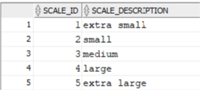

MRE_Feature_Cat_DIM_L2

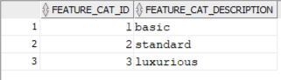

MRE_Property_DIM_L2

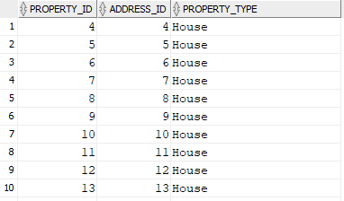

MRE_Property_Feature_Bridge_L2

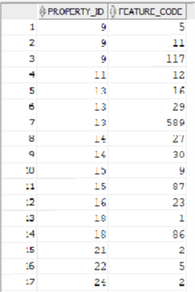

MRE_Feature_DIM_L2

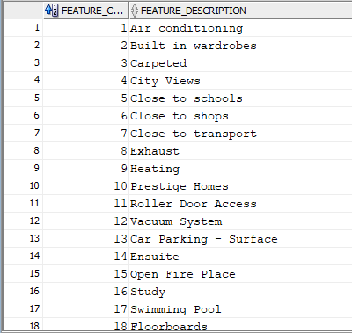

MRE_Property_Type_DIM_L2

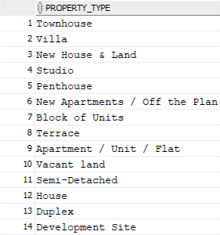

MRE_Address_DIM_L2

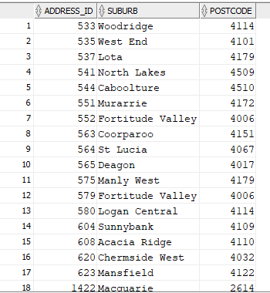

MRE_Postcode_DIM_L2

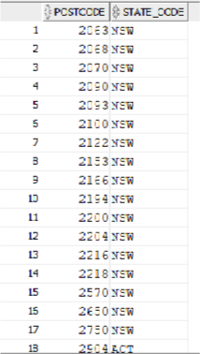

MRE_State_DIM_L2

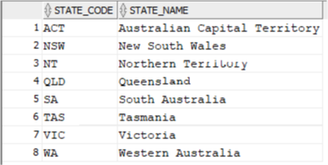

MRE_Advertisement_DIM_L2

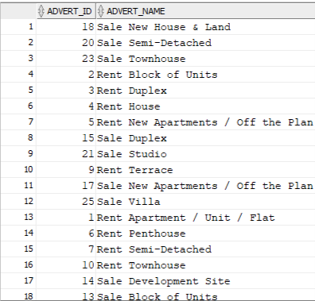

MRE_Person_DIM_L2

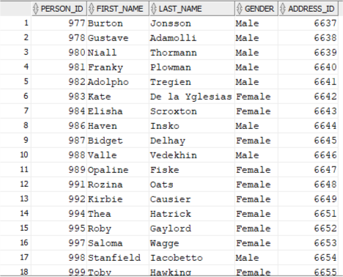

MRE_Agent_Office_DIM_L2

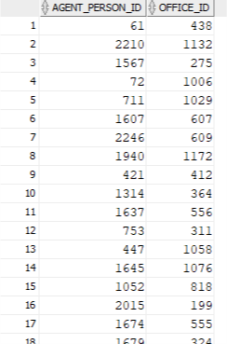

MRE_Office_DIM_L2

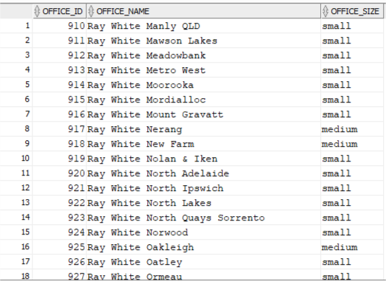

MRE_Budget_DIM_L2

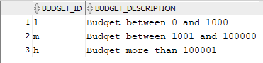

MRE_Rental_Period_DIM_L2

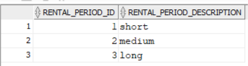

MRE_Wishlist_DIM_L2

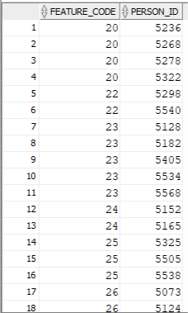

MRE_Rent_Price_DIM_L2

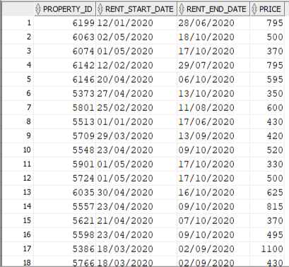

MRE_Temp_Time_DIM_L2

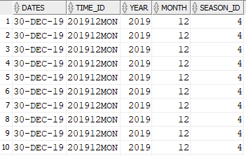

MRE_Time_DIM_L2

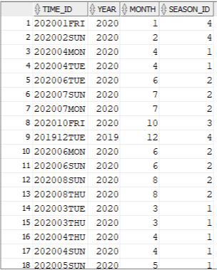

MRE_Season_DIM_L2

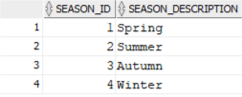

MRE_Agent_FACT_L2

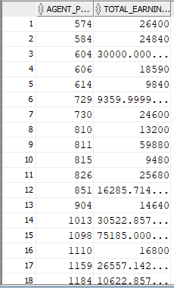

MRE_Temp_Client_L2

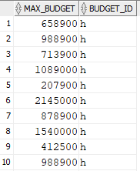

MRE_Client_FACT_L2

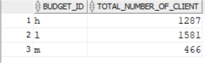

MRE_Temp_Rent_FACT_L2

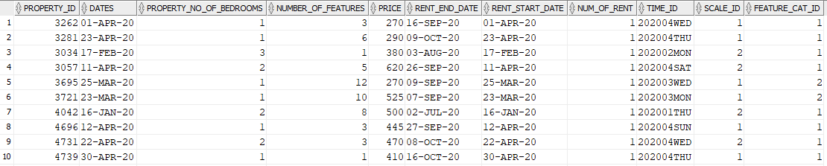

MRE_Rent_FACT_L2

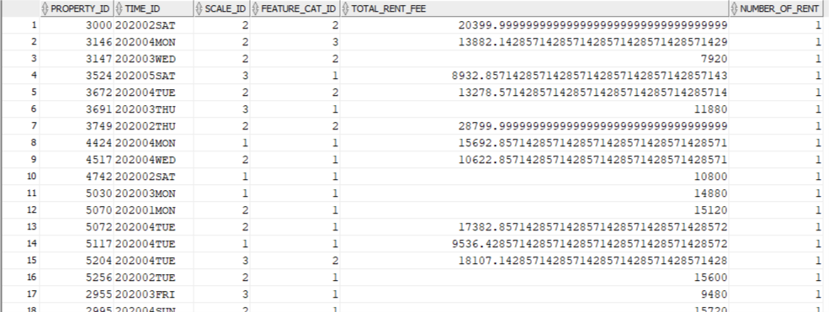

MRE_Temp_Visit_L2

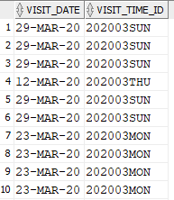

MRE_Visit_FACT_L2

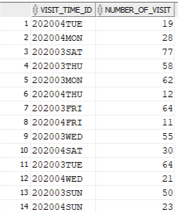

MRE_Temp_Sale_FACT_L2

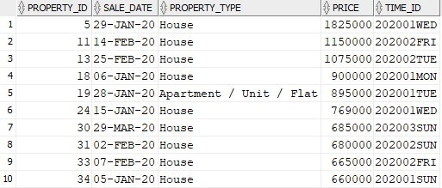

MRE_Sale_FACT_L2

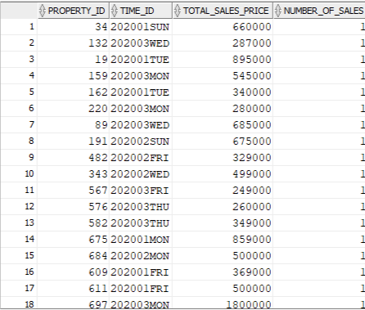

MRE_Temp_Advert_L2

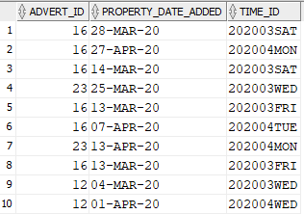

MRE_Advert_FACT_L2

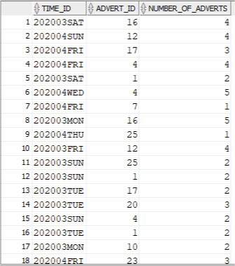

### c2 Level 0 Star Schema

MRE_Scale_DIM_L0

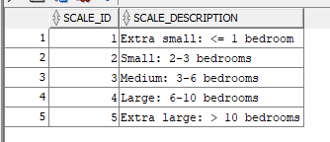

MRE_Feature_Cat_DIM_L0

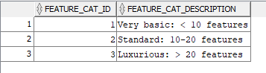

MRE_Property_DIM_L0

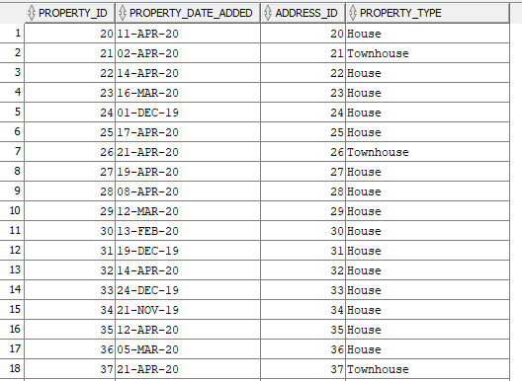

MRE_Property_Feature_Bridge_L0

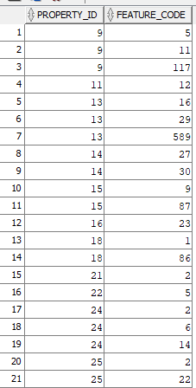

MRE_Feature_DIM_L0

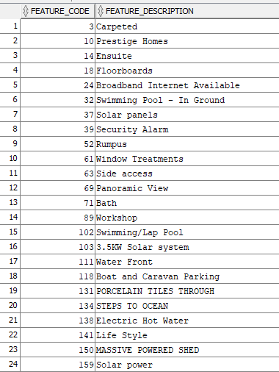

MRE_Wishlist_DIM_L0

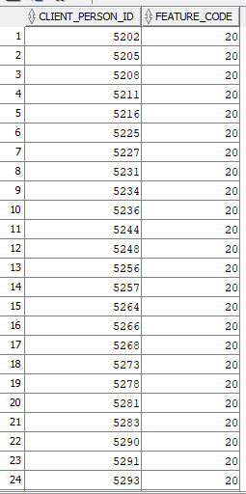

MRE_Property_Type_DIM_L0

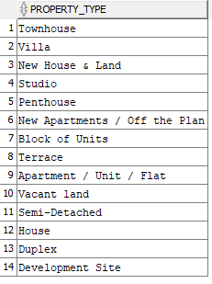

MRE_Address_DIM_L0

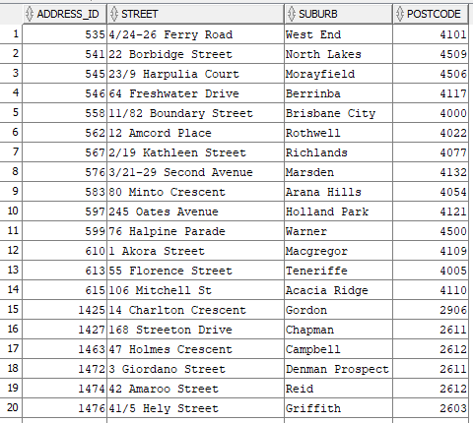

MRE_Postcode_DIM_L0

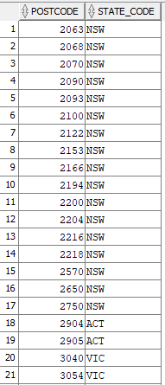

MRE_State_DIM_L0

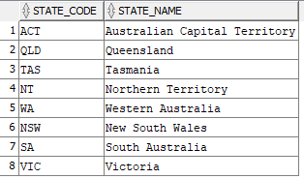

MRE_Advertisement_DIM_L0

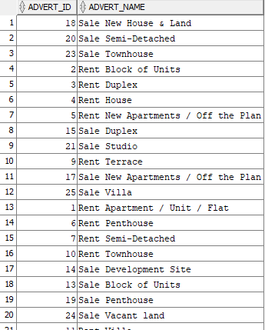

MRE_Person_DIM_L0

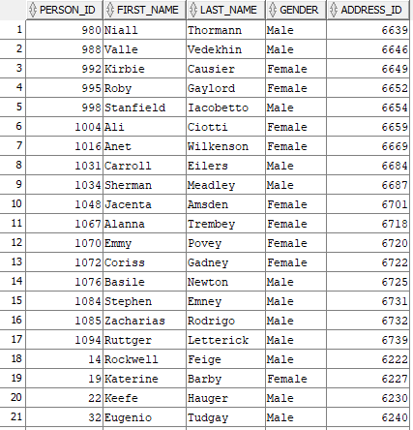

MRE_Agent_Office_DIM_L0

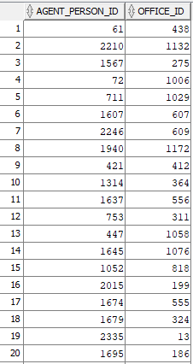

MRE_Office_TempDIM_L0

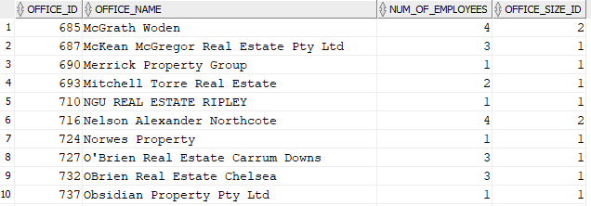

MRE_Office_DIM_L0

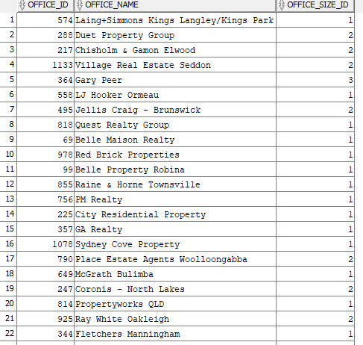

MRE_Office_Size_DIM_L0

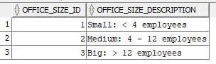

MRE_Budget_DIM_L0

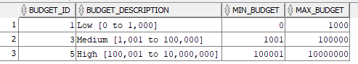

MRE_Rental_Period_DIM_L0

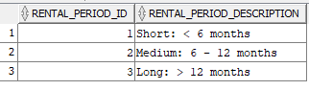

MRE_Rent_Price_DIM_L0

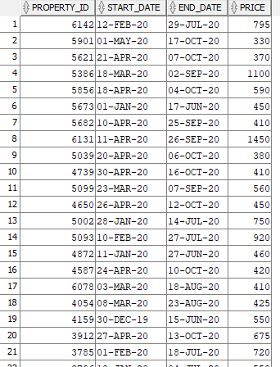

MRE_Season_DIM_L0

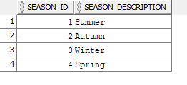

MRE_Time_DIM_L0

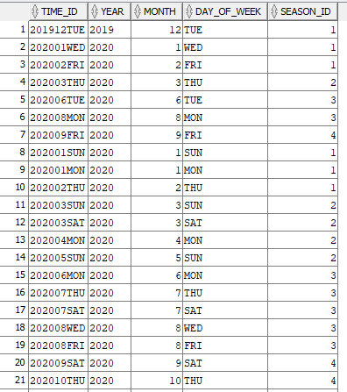

MRE_Sale_FACT_L0

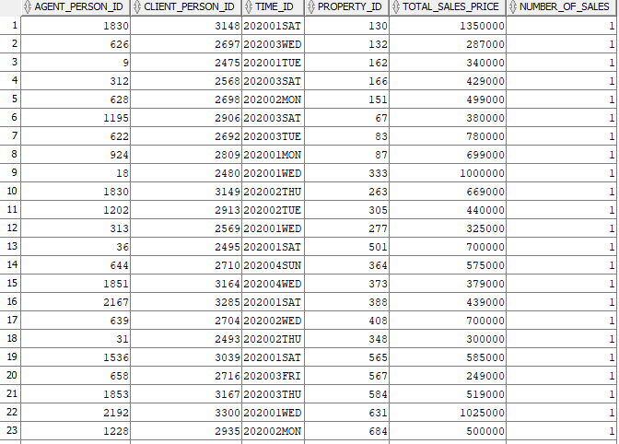

MRE_Rent_TempFACT_L0

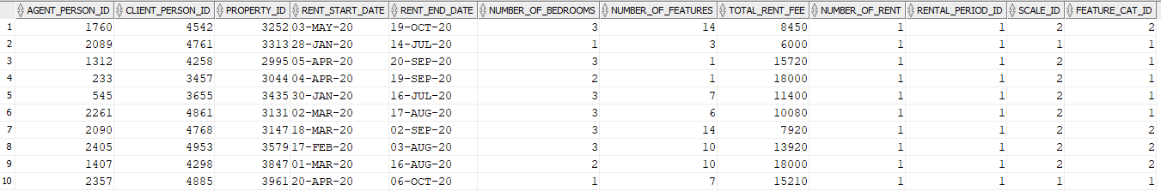

MRE_Rent_FACT_L0

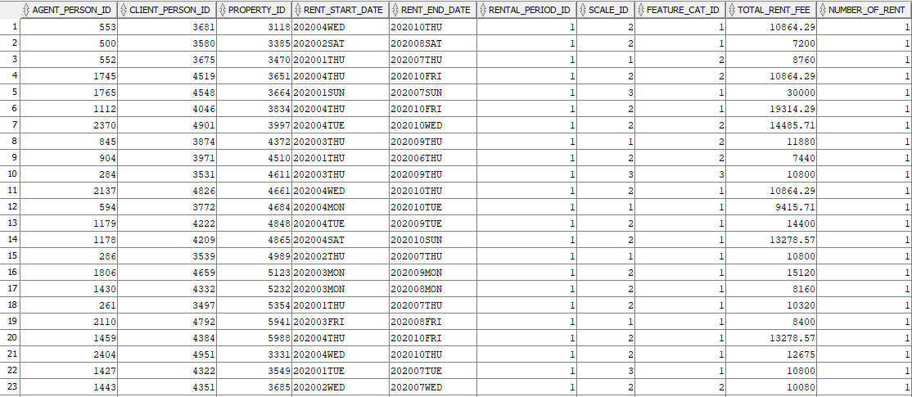

MRE_Client_TempFACT_L0

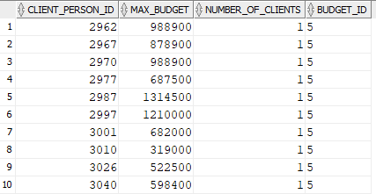

MRE_Client_FACT_L0

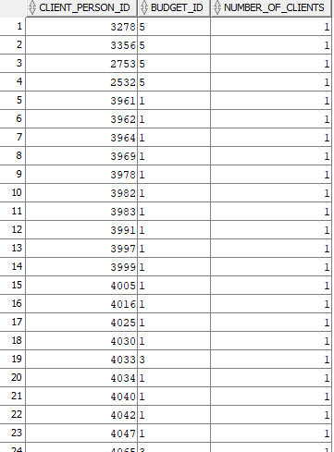

MRE_Agent_FACT_L0

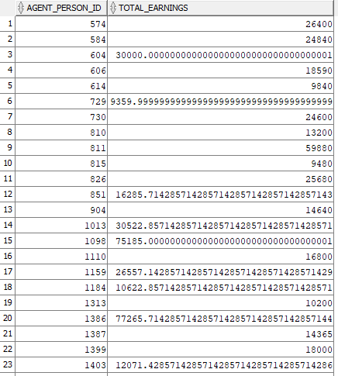

MRE_Visit_FACT_L0

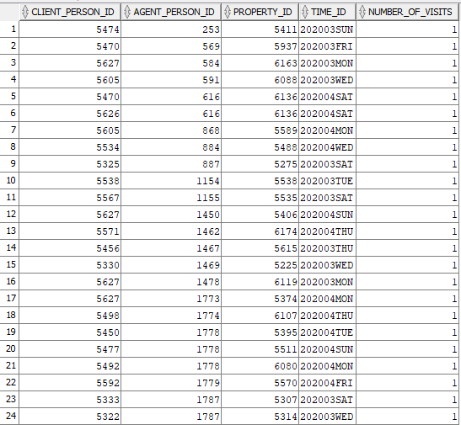

MRE_Advert_FACT_L0

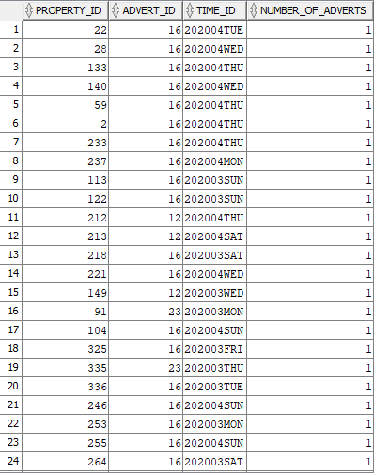

# Task C.3

## Simple Reports

**Report 1**

1. **The query questions written in English**

Top 15 most rented property by scale and suburb.

1. **Your explanation on why such a query is necessary or useful for the management**

This will allow the management to get the sentiment of the rental market.

1. **The SQL commands**

SELECT *

FROM

(SELECT s.scale_description as Scale,

a.suburb as Suburb,

SUM(f.number_of_rent) as Number_of_Rents,

ROW_NUMBER() OVER(ORDER BY SUM(f.number_of_rent)

DESC) as RANK

FROM mre_rent_fact_l2 f, mre_scale_dim_l2 s, mre_property_dim_l2 p, mre_address_dim_l2 a

WHERE f.scale_id = s.scale_id

AND f.property_id = p.property_id

AND p.address_id = a.address_id

GROUP BY s.scale_description, a.suburb

ORDER BY ROW_NUMBER() OVER(ORDER BY

SUM(f.number_of_rent) DESC) ASC)

WHERE RANK <= 15;

1. **The screenshots of the query results (or part of the query results), including all the attribute names**

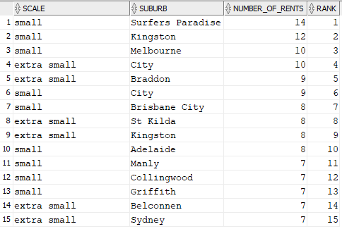

**Report 2**

1. **The query questions written in English**

Top 15% sales based on time period and property type.

1. **Your explanation on why such a query is necessary or useful for the management**

This might give the management an idea to focus on which suburb at what time to boast business performance.

1. **The SQL commands**

SELECT *

FROM (

SELECT t.year as Year,

t.month as Month,

p.property_type as Property_Type,

SUM(f.total_sales_price) as Total_Sales_Price,

SUM(f.number_of_sales) as Number_of_Sales,

PERCENT_RANK() OVER (ORDER BY SUM(f.total_sales_price) DESC) as Revenue_Ranking

FROM mre_sale_fact_l2 f, mre_property_dim_l2 p, mre_time_dim_l2 t

WHERE f.time_id = t.time_id

GROUP BY t.year, t.month, p.property_type)

WHERE Revenue_Ranking >= 0.85

ORDER BY Revenue_Ranking DESC;

1. **The screenshots of the query results (or part of the query results), including all the attribute names**

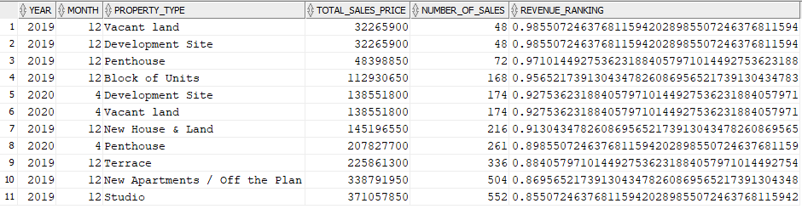

**Report 3**

1. **The query questions written in English**

Total property visited by suburb and season.

1. **Your explanation on why such a query is necessary or useful for the management**

This will give the management and insight of property investment of different locations and seasons

1. **The SQL commands**

SELECT t.year as Year,

s.season_description as season,

a.suburb as suburb,

SUM(number_of_visits) as Number_of_Visits

FROM mre_visit_fact_l0 f, mre_time_dim_l0 t,

mre_season_dim_l0 s, mre_property_dim_l0 p, mre_address_dim_l0 a

WHERE f.time_id = t.time_id

AND t.season_id = s.season_id

AND f.property_id = p.property_id

AND p.address_id = a.address_id

GROUP BY t.year, s.season_description, a.suburb

ORDER BY t.year, s.season_description,

a.suburb;

1. **The screenshots of the query results (or part of the query results), including all the attribute names**

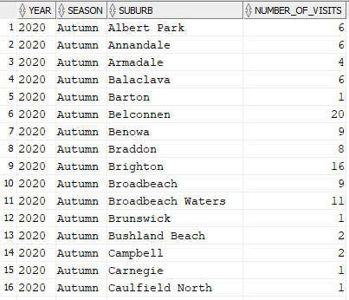

## Reports with proper sub-totals

**Report 4**

1. **The query questions written in English**

What are the sub-total and total rental fees from each suburb, time period, and property type?

1. **Your explanation on why such a query is necessary or useful for the management**

This will give the management an idea of different combinations between suburb, time period and property type.

1. **The SQL commands**

SELECT t.year||t.month as Time_Period,

a.suburb as Suburb,

p.property_type as Property_Type,

to_char(SUM(f.total_rent_fee), '9,999,999,999.99')

as Rental_Fees,

DECODE(GROUPING(t.year||t.month), 1, 'All Periods',

t.year||t.month) as Period,

DECODE(GROUPING(a.suburb), 1, 'All Suburbs',

a.suburb) as Suburbs,

DECODE(GROUPING(p.property_type), 1, 'All Types',

p.property_type) as Types

FROM mre_rent_fact_l2 f, mre_time_dim_l2 t, mre_property_dim_l2 p, mre_address_dim_l2 a

WHERE f.time_id = t.time_id

AND f.property_id = p.property_id

AND p.address_id = a.address_id

GROUP BY CUBE(t.year||t.month, a.suburb, p.property_type);

1. **The screenshots of the query results (or part of the query results), including all the attribute names**

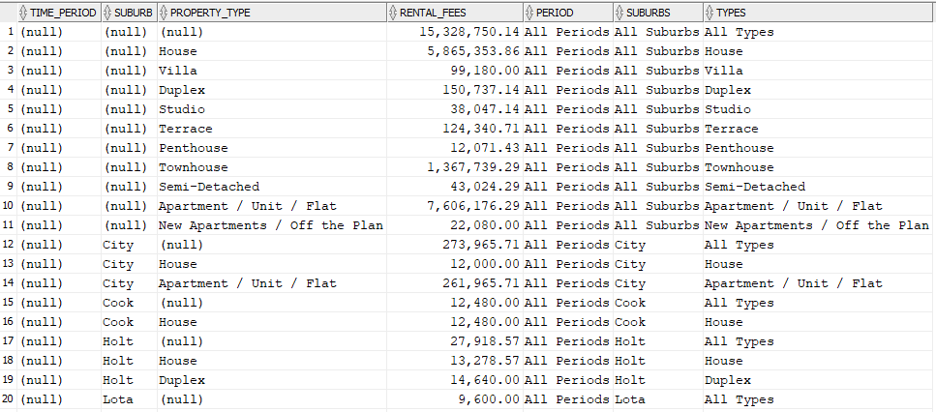

**Report 5**

1. **The query questions written in English**

What are the sub-total and total rental fees from each suburb, time period, and property type?

1. **Your explanation on why such a query is necessary or useful for the management**

This will give the management an idea of different combinations between suburb, time period and property type.

1. **The SQL commands**

SELECT t.year||t.month as Time_Period,

a.suburb as Suburb,

p.property_type as Property_Type,

to_char(SUM(f.total_rent_fee), '9,999,999,999.99')

as Rental_Fees,

DECODE(GROUPING(t.year||t.month), 1, 'All Periods',

t.year||t.month) as Period,

DECODE(GROUPING(a.suburb), 1, 'All Suburbs',

a.suburb) as Suburbs,

DECODE(GROUPING(p.property_type), 1, 'All Types',

p.property_type) as Types

FROM mre_rent_fact_l2 f, mre_time_dim_l2 t, mre_property_dim_l2 p, mre_address_dim_l2 a

WHERE f.time_id = t.time_id

AND f.property_id = p.property_id

AND p.address_id = a.address_id

GROUP BY a.suburb, CUBE(t.year||t.month,

p.property_type);

1. **The screenshots of the query results (or part of the query results), including all the attribute names**

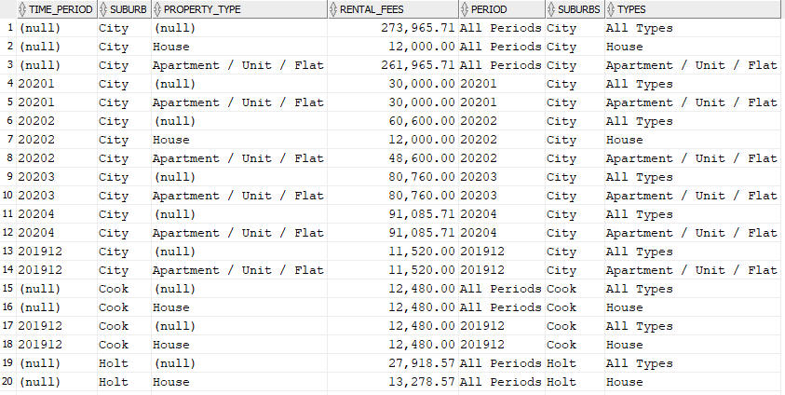

**Report 6**

1. **The query questions written in English**

What is the sub-total and total sale revenue from each state and time period for houses?

1. **Your explanation on why such a query is necessary or useful for the management**

This will give the management an understanding of sale of one of their best sellers, houses, at different states and time periods.

1. **The SQL commands**

SELECT t.year||t.month as Time_period,

st.state_name as State,

SUM(s.total_sales_price) as Total_Revenue,

DECODE(GROUPING(t.year||t.month), 1, 'All Periods',

t.year||t.month) as Periods,

DECODE(GROUPING(st.state_name), 1, 'All States',

st.state_name) as States

FROM mre_sale_fact_l2 s, mre_property_dim_l2 p,

mre_address_dim_l2 a, mre_postcode_dim_l2 pc,

mre_state_dim_l2 st, mre_time_dim_l2 t

WHERE s.property_id = p.property_id

AND p.address_id = a.address_id

AND a.postcode = pc.postcode

AND pc.state_code = st.state_code

AND s.time_id = t.time_id

AND p.property_type = 'House'

GROUP BY ROLLUP (t.year||t.month,

st.state_name);

1. **The screenshots of the query results (or part of the query results), including all the attribute names**

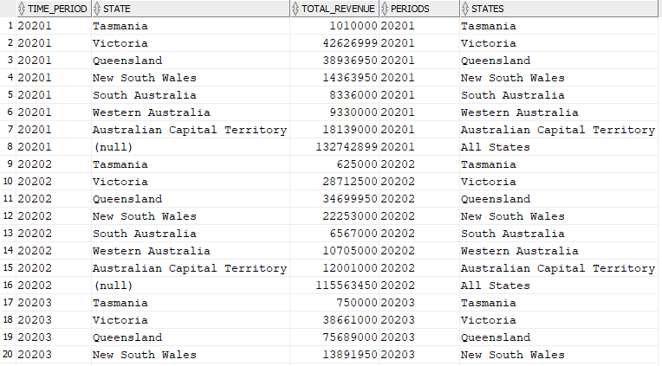

**Report 7**

1. **The query questions written in English**

What is the sub-total and total sale revenue from each state and time period for houses?

1. **Your explanation on why such a query is necessary or useful for the management**

This will give the management an understanding of sale of one of their best sellers, houses, at different states and time periods.

1. **The SQL commands**

SELECT t.year||t.month as Time_period,

st.state_name as State,

SUM(s.total_sales_price) as Total_Revenue,

DECODE(GROUPING(t.year||t.month), 1, 'All Periods',

t.year||t.month) as Periods,

DECODE(GROUPING(st.state_name), 1, 'All States',

st.state_name) as States

FROM mre_sale_fact_l2 s, mre_property_dim_l2 p, mre_address_dim_l2 a, mre_postcode_dim_l2 pc, mre_state_dim_l2 st, mre_time_dim_l2 t

WHERE s.property_id = p.property_id

AND p.address_id = a.address_id

AND a.postcode = pc.postcode

AND pc.state_code = st.state_code

AND s.time_id = t.time_id

AND p.property_type = 'House'

GROUP BY st.state_name, ROLLUP

(t.year||t.month);

1. **The screenshots of the query results (or part of the query results), including all the attribute names**

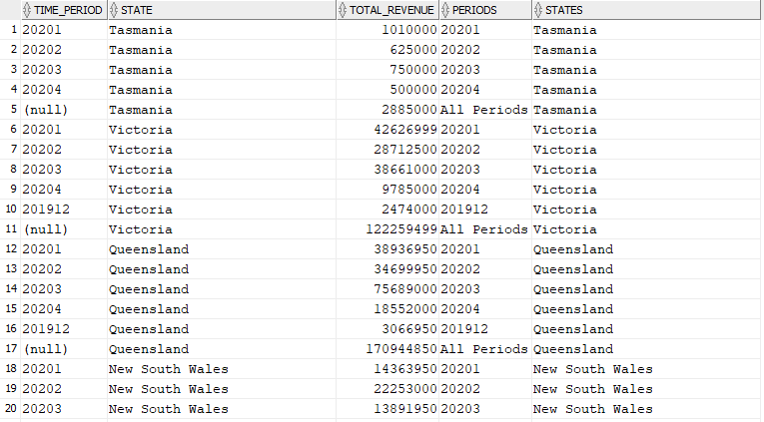

## Reports with moving and cumulative aggregates

**Report 8**

1. **The query questions written in English**

What is the total number of clients and cumulative number of clients with a high budget in each year?

1. **Your explanation on why such a query is necessary or useful for the management**

This will give the management an understanding of how high budget clients have chosen MonRE as their preferred agency.

1. **The SQL commands**

SELECT year,

SUM(total_clients) as Number_of_Clients,

SUM(SUM(total_clients)) OVER (ORDER BY year ROWS

UNBOUNDED PRECEDING) as Cumulative_Total

FROM

(SELECT *

FROM

(SELECT t.year, SUM(f.number_of_clients) as total_clients

FROM mre_client_fact_l0 f, mre_budget_dim_l0 b, mre_rent_fact_l0 rf, mre_time_dim_l0 t

WHERE f.budget_id = b.budget_id

AND f.client_person_id = rf.client_person_id

AND rf.rent_start_date = t.time_id

AND b.budget_description LIKE 'High%'

GROUP BY t.year)

UNION

(SELECT t.year, SUM(f.number_of_clients) as total_clients

FROM mre_client_fact_l0 f, mre_budget_dim_l0 b, mre_sale_fact_l0 sf, mre_time_dim_l0 t

WHERE f.budget_id = b.budget_id

AND f.client_person_id = sf.client_person_id

AND sf.time_id = t.time_id

AND b.budget_description LIKE 'High%'

GROUP BY t.year))

GROUP BY year

ORDER BY year;

1. **The screenshots of the query results (or part of the query results), including all the attribute names**

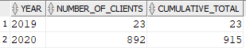

**Report 9**

1. **The query questions written in English**

What is the total monthly number of visits and 3-month average number of visits?

1. **Your explanation on why such a query is necessary or useful for the management**

Management may want to know more about why are there more visits in certain months. They can then drill down to find out which properties are having many visits from different visiting clients.

1. **The SQL commands**

SELECT t.year,

t.month,

SUM(number_of_visit) as Number_of_Visits,

to_char(AVG(SUM(f.number_of_visit)) OVER (ORDER BY

t.year, t.month ROWS 2 PRECEDING), '999,999') as

Average_3_Month_Visits

FROM mre_visit_fact_l2 f, mre_time_dim_l2 t

WHERE f.visit_time_id =t.time_id

GROUP BY t.year, t.month

ORDER BY year, month +0;

1. **The screenshots of the query results (or part of the query results), including all the attribute names**

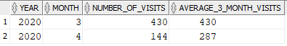

**Report 10**

1. **The query questions written in English**

Cumulative monthly total number of rents based on properties that have been rented to clients.

1. **Your explanation on why such a query is necessary or useful for the management**

Management would have a good indication of cash flow coming from rentals. They can use this information to make decisions on whether to increase spending on attracting tenants.

1. **The SQL commands**

SELECT t.year as Year,

t.month as Month,

SUM(Number_of_Rent) as Number_of_Rents,

SUM(SUM(number_of_rent)) OVER (ORDER BY t.year,

t.month ROWS UNBOUNDED PRECEDING) as

Cumulative_Number_of_Rent

FROM mre_rent_fact_l2 f, mre_time_dim_l2 t

WHERE f.time_id = t.time_id

GROUP BY t.year, t.month

ORDER BY year, month +0;

1. **The screenshots of the query results (or part of the query results), including all the attribute names**

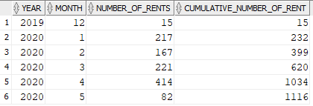

## Reports with Partitions

**Report 11**

1. **The query questions written in English**

Show ranking of each property type based on the yearly total number of sales and the ranking of each state based on the yearly total number of sales.

1. **Your explanation on why such a query is necessary or useful for the management**

This information might to useful to management to see the property type with most sales as well as the state with most sales of each type.

1. **The SQL commands**

SELECT t.year as Year,

p.property_type as Property_Type,

s.state_name as State,

SUM(f.number_of_sales) as Total_Number_of_Sales,

RANK() OVER (PARTITION BY t.year ORDER BY

SUM(f.number_of_sales) DESC) as RANK_BY_YEAR,

RANK() OVER (PARTITION BY s.state_name ORDER BY

SUM(f.number_of_sales) DESC) as RANK_BY_STATE

FROM mre_sale_fact_l2 f, mre_property_dim_l2 p,

mre_time_dim_l2 t, mre_address_dim_l2 a, mre_postcode_dim_l2 pc, mre_state_dim_l2 s

WHERE f.property_id = p.property_id

AND f.time_id = t.time_id

AND p.address_id = a.address_id

AND a.postcode = pc.postcode

AND pc.state_code = s.state_code

GROUP BY t.year, p.property_type, s.state_name

ORDER BY SUM(f.number_of_sales) DESC;

1. **The screenshots of the query results (or part of the query results), including all the attribute names**

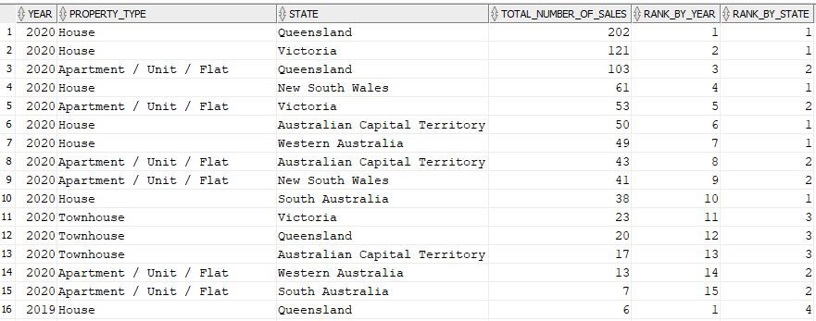

**Report 12**

1. **The query questions written in English**

Show ranking of each advertisement type based on the yearly total number of adverts and the ranking of each state based on the yearly total number of adverts.

1. **Your explanation on why such a query is necessary or useful for the management**

This information might be useful to management to compare the number of advertisements of different types and different states to observe sale patterns of certain areas.

1. **The SQL commands**

SELECT t.year as Year,

ad.advert_name as Advertisement_Type,

s.state_name as State,

SUM(f.number_of_adverts) as

Yearly_Total_Number_of_Adverts,

RANK() OVER (PARTITION BY ad.advert_name ORDER BY

SUM(f.number_of_adverts) DESC) as

RANK_BY_ADVERT_TYPE,

RANK() OVER (PARTITION BY s.state_name ORDER BY

SUM(f.number_of_adverts) DESC) as RANK_BY_STATE

FROM mre_advert_fact_l0 f, mre_advertisement_dim_l0 ad, mre_property_dim_l0 p, mre_address_dim_l0 a, mre_postcode_dim_l0 pc, mre_state_dim_l0 s, mre_time_dim_l0 t

WHERE f.advert_id = ad.advert_id

AND f.property_id = p.property_id

AND p.address_id = a.address_id

AND a.postcode = pc.postcode

AND pc.state_code = s.state_code

AND f.time_id = t.time_id

GROUP BY t.year, ad.advert_name, s.state_name

ORDER BY SUM(f.number_of_adverts) DESC;

1. **The screenshots of the query results (or part of the query results), including all the attribute names**

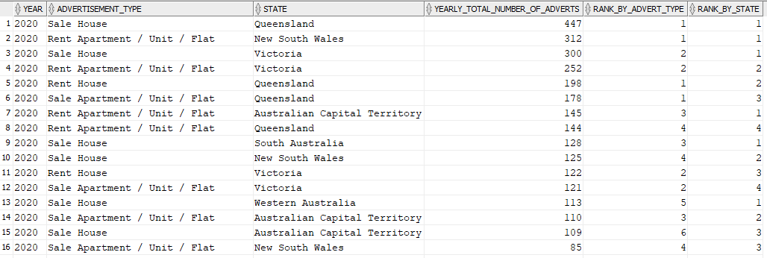

# Task 4

**Report 2**

Top 15% sales based on time period and property type.

**Report 3**

Total property visited by suburb and season.

**Report 8**

What is the total number of clients and cumulative number of clients with a high budget in each year?

**Report 9**

What is the total monthly number of visits and 3-month average number of visits?

**Report 10**

Cumulative monthly total number of rents based on properties that have been rented to clients

